Two-point discrimination:
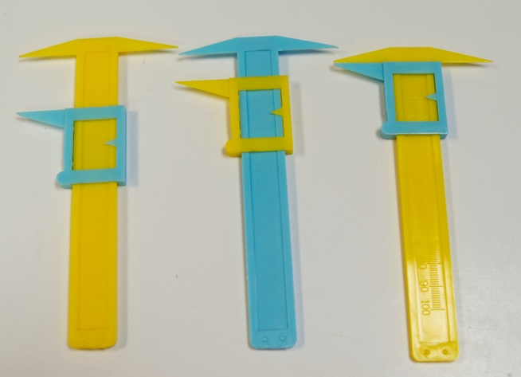
Materials: Several 2 point discriminator calipers. Make sure that when the sliding part is pushed all the way up, the 2 sharp ends form what feels like a single point on the pad of your index finger. (If this is not the case, don’t use it.) Ask rowdy children to be careful with the calipers, as they are easily bent out of shape.
Supplier: Carolina, Item #696417
Cost: $8.50 each

Here’s how it works:
- Two people are required. One person administers the test, the other is the volunteer. If business is slow, you can administer the test. If there are many people around, tell them to pair up and take turns with each role.
- Ask the volunteer to put out the tip of their index finger and close their eyes. Start with the caliper closed (2 sharp points feel like 1 point). Ask the volunteer how many points they feel (should be 1). Slowly slide down the moveable piece of the caliper while re-poking the volunteer until they say they can feel 2 points, and note how wide the caliper is open at this time. (For the tip of the index finger, people can often feel the 2 points as soon as the caliper is visibly open)
- Next, test another part of the body. The cheek works very well (and is convenient in winter if everyone is wearing jackets), the upper arm also can work. [At this point, you can ask older students whether they think the distance required to feel the 2 points will be the same or larger than for the tip of the finger. Point out that this is their hypothesis.] Again, start with the caliper closed, where the volunteer should feel only 1 point. Slowly open the caliper while re-poking until the volunteer feels 2 points. The distance required to feel the 2 points should be much greater than for the tip of the index finger. Point this out.

Explanation:
Our sense of touch is mediated by sensory receptors, which are all over our skin. The density of receptors is different for various parts of the body. This makes sense, right? We need to be able our touch to be more sensitive for the tip of the index finger than for our cheek, so we can use our fingers to do intricate things like type, or sew or play a musical instrument.

Extended explanation:
The density of sensory receptors for various parts of the body are coordinated with the size of the brain region that interprets these signals. The brain region involved in interpreting sensory signals forms what is called a homunculus (see figures on next page). Homunculus means little man. Here is a diagram that represents the size of the brain region designated for each part of the body. Notice how big the lips and fingers are, which have a very high density of sensory receptors, compared to the stomach and legs, which have lower densities of sensory receptors.

Additional activities for classroom setting:
For a classroom lesson, students can test various parts of the body. Good areas to test include the fingertips, shoulder, elbow, forearm, palm, or back of the hand. The subject reports whether they sense one or two distinct points each time the tester touches. The tester records the measurement of the smallest opening of the calipers (in mm) at which the subject correctly identifies two distinct points. By testing different areas, the students will discover that some parts of their bodies are better able to discriminate between the two points than other areas. Have students record their measurements and present their data. This is a great activity for creating group statistics by pooling and averaging the recordings from all the groups in the class – create a histogram on the board for each area of the body.

See Eric Chudler’s section on this activity and its background concepts here (very useful): http://faculty.washington.edu/chudler/twopt.html
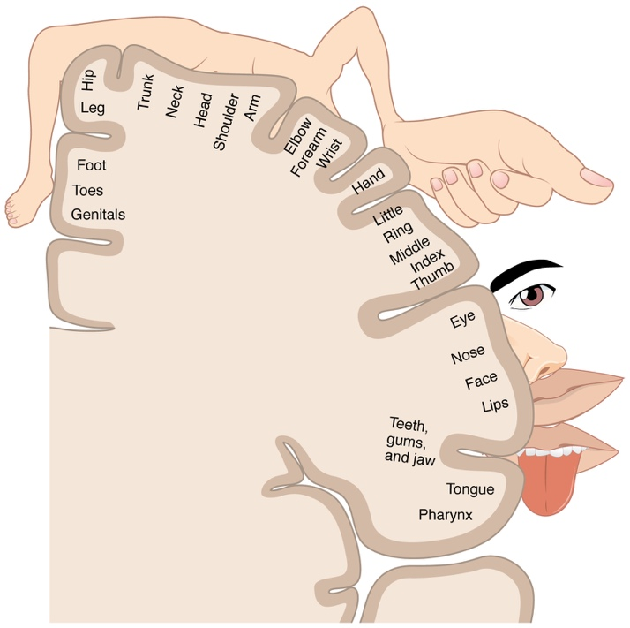
From: https://upload.wikimedia.org/wikipedia/commons/c/c4/1421_Sensory_Homunculus.jpg

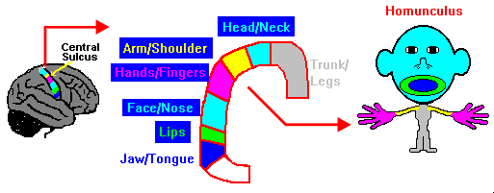
from: http://faculty.washington.edu/chudler/twopt.html

