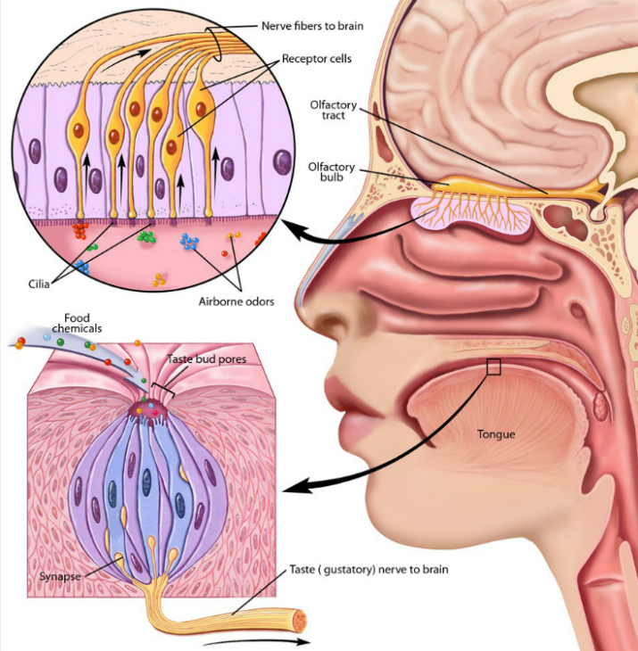

**Flavor is a combination**

**of smell and taste**

**The Jelly Bean Experiment**

1. Hold your nose with your fingers.
2. Close your eyes and stick out your hand.
3. You will be given a jellybean.
4. With your eyes and nose closed, try to guess what kind of jellybean you have.
5. Now open up your nose and then see if you can tell what kind of jellybean you as closed, what could you tell about the jellybean? What could you not notice?

* How is the experience different with your nose open vs. closed?
* When your nose was closed, what could you tell about the jellybean? What could you not notice?

**What is a taste?**

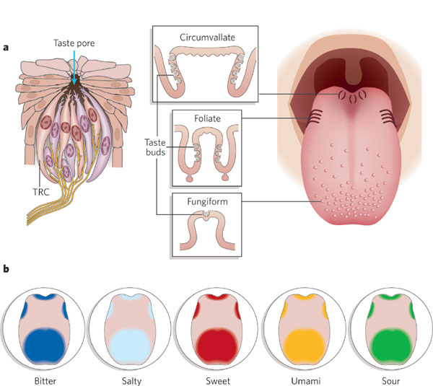

**Taste Buds on the Tongue**

* **Taste receptor cells** are in **taste buds**
* Each cell has only **one type** of receptor
* Each taste bud has cells of every type
* Receptor cells connect to the brain

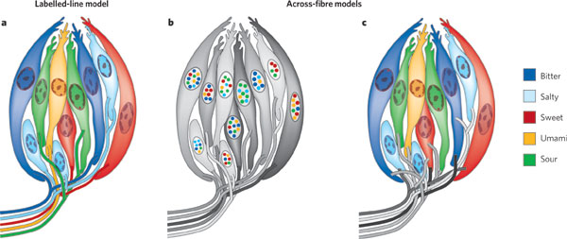

**Our brain discerns 5 tastes:**

Sweet 🡪 energy

Sour 🡪 rotten food

Bitter 🡪 poisons

Salty 🡪 electrolytes

Umami 🡪 protein

**The brain has dedicated areas for each of the 5 basic tastes**

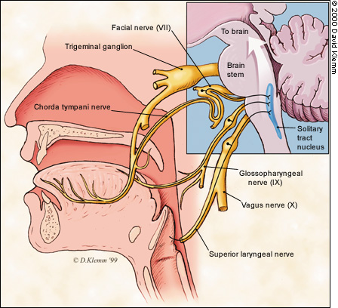

**3 Nerves Carry Taste Information to the Brain**

**Examples of different**

**flavors of jelly beans**

**What is a smell?**

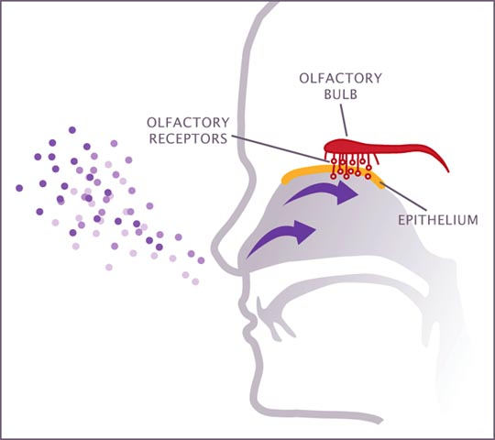

* We have 100’s of different smell receptors
* Receptors can tell apart very similar chemicals
* 3% of human DNA encodes smell receptors
* An **odor** is a combination of activity from several receptors

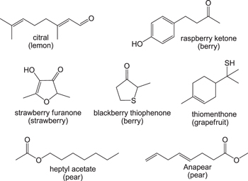

We can smell

**millions** of different odors

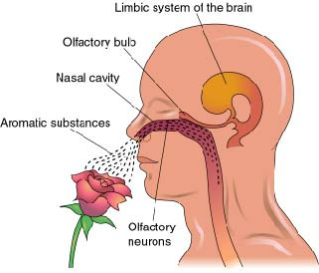

**Smell information goes directly to brain areas for emotion and memory**

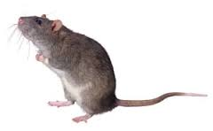

Some animals experience the world primarily through smell

**THE JELLY BEAN CHALLENGE**